\\ui.uillinois.edu\ds\dsinternal\1.Administration\Communications\DS Website\Clouds\orig_AITS\images\logo.gif

**Decision Support** – AITS

University Administration

Connecting to OLAP cubes

Using Excel 2016

1

Table of Contents:

* Requesting Access
* Connecting the first time
* Connecting the next time
* Appendix – First Time Connection Problems

# Requesting Access

* In order to connect to an AITS – Decision Support OLAP cube, you must first get access to it.
* In order to get approved for access, you must have access to the relevant subject data in the EDW. If you do not have access, your USC must request access to it.
* If you have access to the relevant subject data in the EDW, your Unit Security Contact (USC) can submit a request specifically for the OLAP cube access.

Once you have access, open Excel.

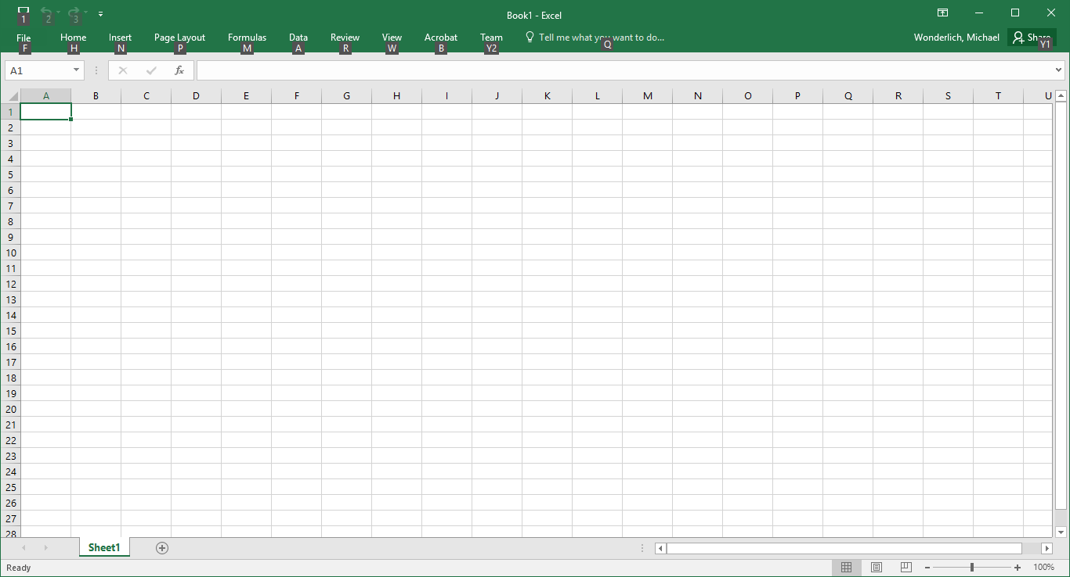

Go to the Data tab.

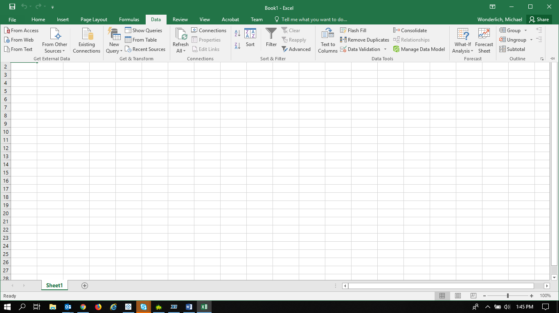

From the “From Other Sources” menu, select “From Analysis Services.”

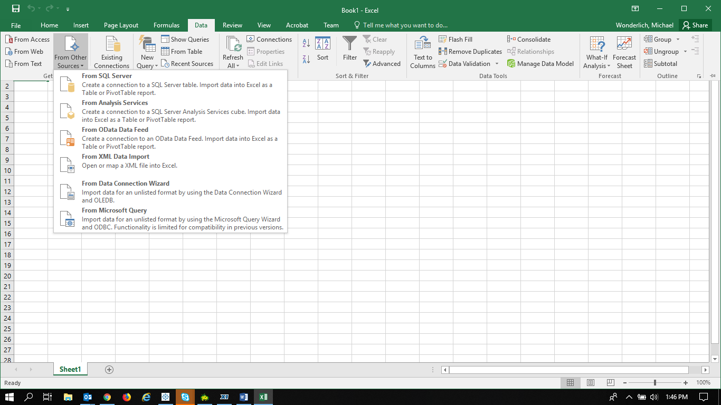

Fill in the information in the Data Connection Wizard.

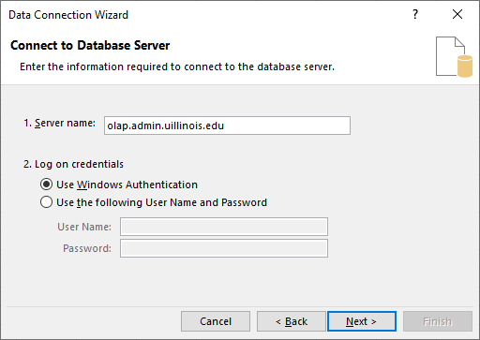

1. In Server Name, type: “olap.admin.uillinois.edu”
2. Most units use the campus Active Directory. If your unit does, you can use Windows Authentication.
3. Click Next

If you do not use Active Directory, you will receive the below error message:

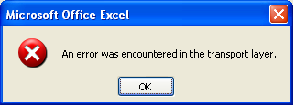

* If you receive the above error, go to the **Appendix** to see additional instructions for accessing the cube.

Select the appropriate OLAP cube in the dropdown menu and highlight the name.

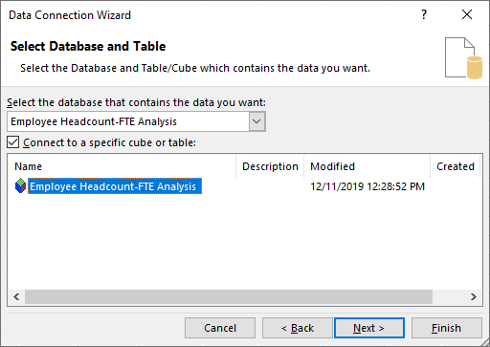

This example uses the Headcount FTE cube. Your available options will vary depending on your access.

# Click on Finish.

,

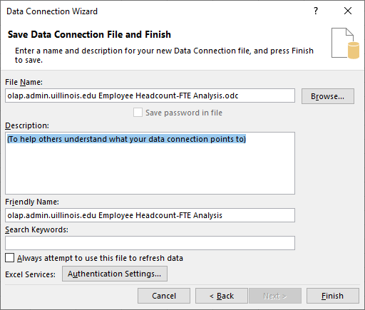

## The data connection wizard wants to start the Pivot Table at A1. Click “OK.”

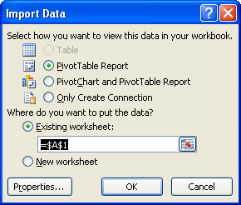

You are now ready to start using the OLAP cube.

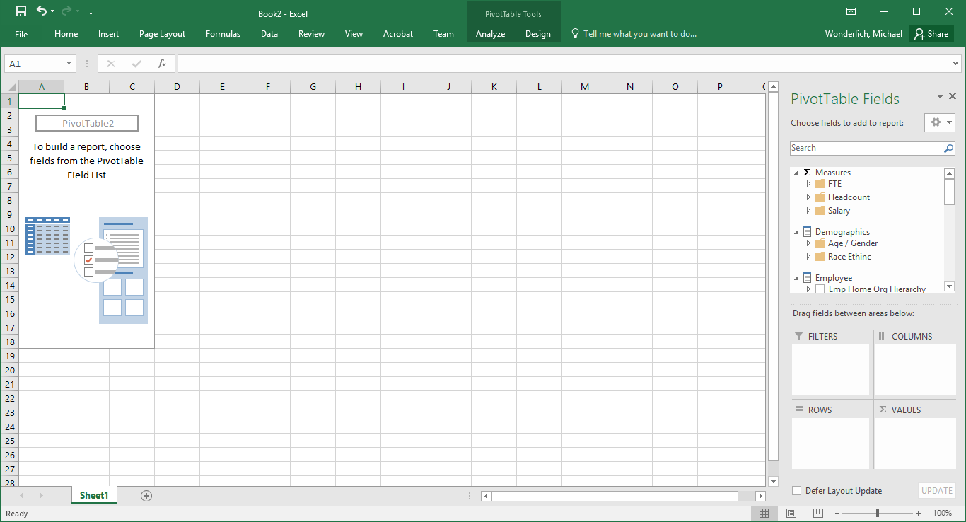

Connecting to the cube next time

* After you have connected to the cube once, the next time you need to connect to it will be much easier.



# Start in Excel at the Data tab.

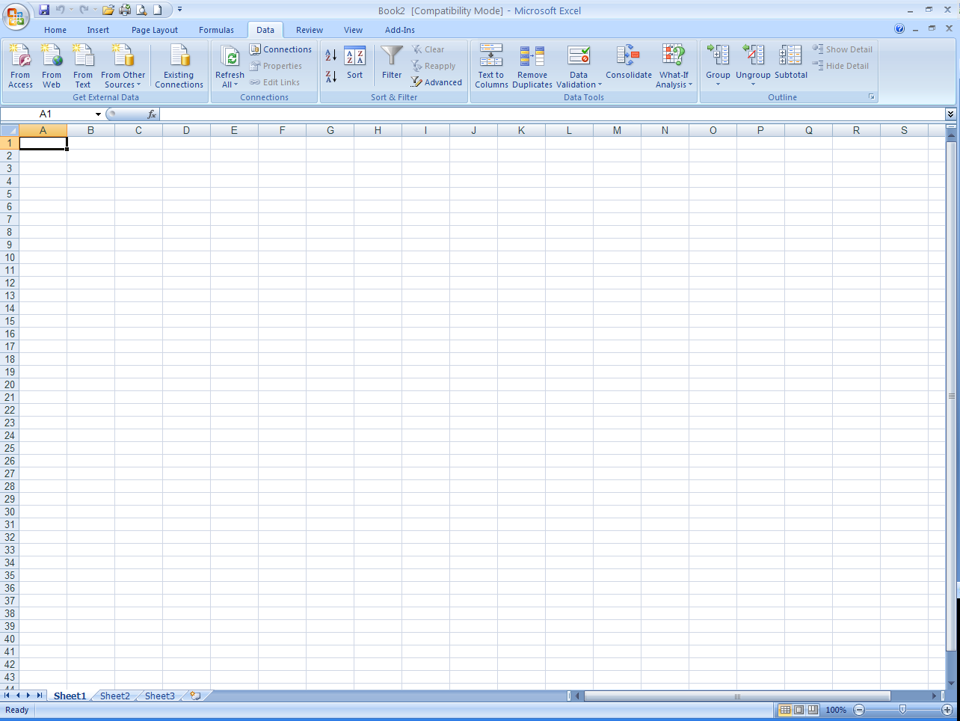

## This time select Existing Connections.

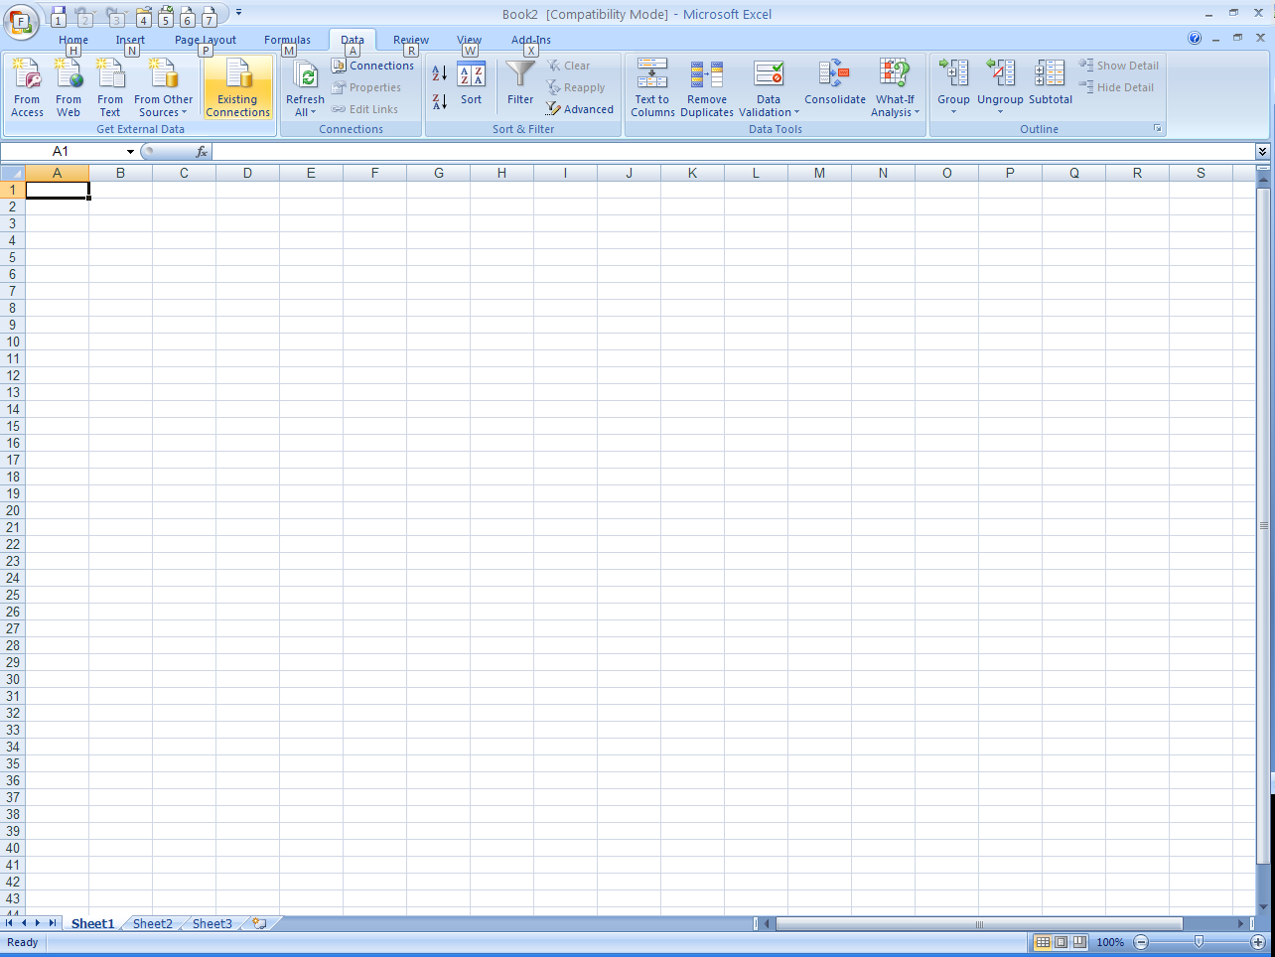

Select “olap.admin.uillinois.edu Employee Headcount FTE Analysis.”

This example uses the Headcount OLAP cube. The connection will start with olap.admin.uillinois.edu . The cube name will vary.

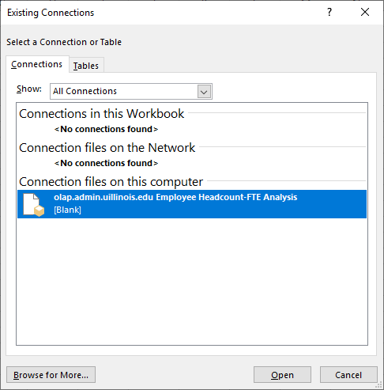

## The data connection wizard wants to start the Pivot Table at A1. Click “OK.”



You are now ready to start using the OLAP cube.

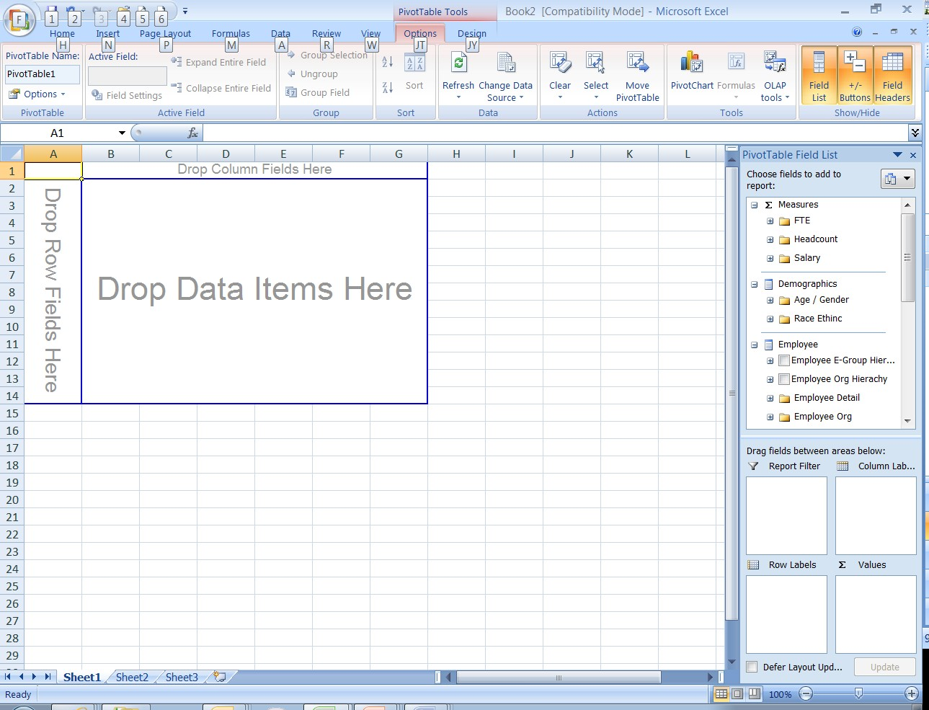

Appendix

**First Time Connection Problems**

## If you receive an error message, try this method:

* 1. 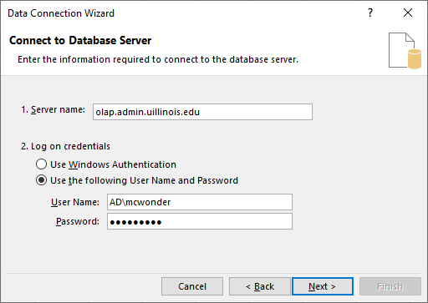 In Server Name, type:

“olap.admin.uillinois.edu”

* 1. Click on the radio button, next to “Use the following User Name and Password.”
  2. In User Name:
     1. ***At UIC***, enter “AD” or “AD.uic.edu” followed by a backslash and your username (AD.uic.edu\username).
     2. ***At UIS***, enter “UISAD” followed by a backslash and your username (UISAD\username).
     3. ***At UIUC***, enter “UIUC” followed by a backslash and your username (UIUC\username).
  3. In Password, enter your Net ID password.

20 5. Click ‘Next.”

Copyright © 2010 The Board of Trustees of the University of Illinois

# Click on Authentication Settings…

For Excel 2016, select “None.”

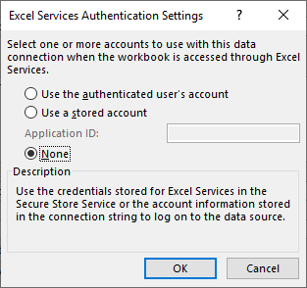For earlier versions of Excel, select SSO.

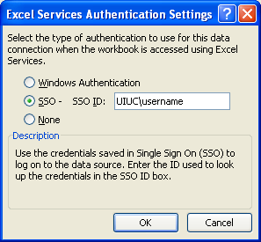

1. In SSO ID:
   1. ***At UIC***, enter “AD.uic.edu” followed by a backslash and your username (AD.uic.edu\username).
   2. ***At UIS***, enter “UISAD” followed by a backslash and your username (UISAD\username).
   3. ***At UIUC***, enter “UIUC” followed by a backslash and your username (UIUC\username).
2. Click “OK.”

Click “Save password to file.”

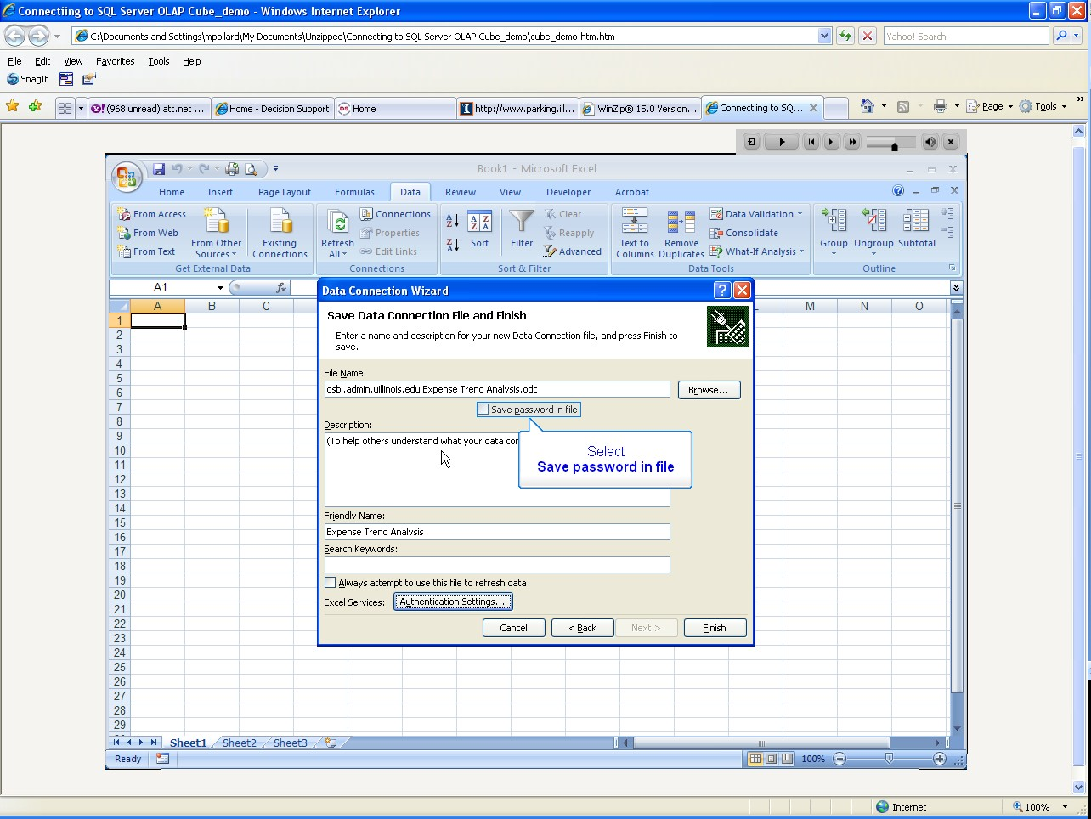

## You will receive a warning message that your password is saved on your computer.

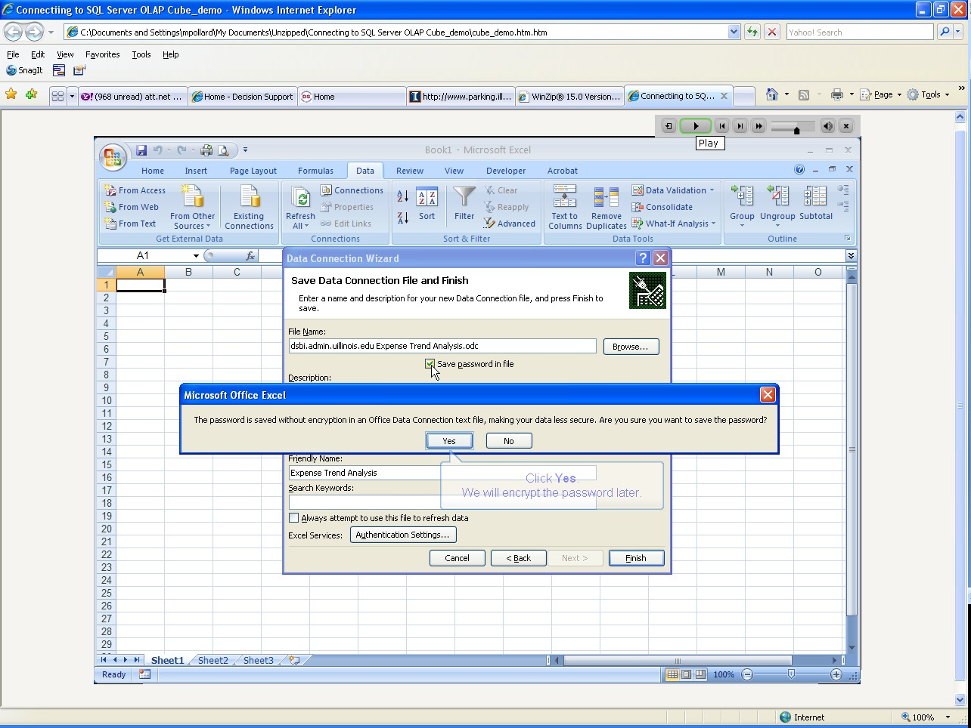

Select the OLAP cube in the dropdown menu and highlight the name.

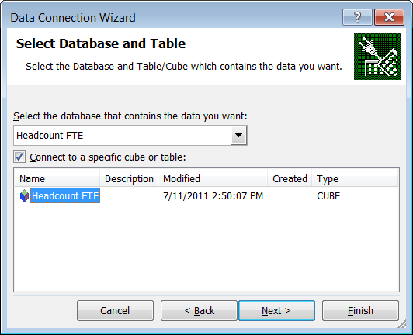

This example uses the Headcount FTE cube. Your available options will vary depending on your access.

## The data connection wizard wants to start the Pivot Table at A1. Click “OK.”



You are now ready to start using the OLAP cube.



If you are still having connection problems:

* Please send an email to Decision Support User Support Specialists (dsuss@uillinois.edu)

